LINUX DISTRIBUTION AND SHELL

Q3.which is the following is not a shell

ANS: b) perl shell

**Q1.HOW TO GET A LIST OF SHELL PRESENTS ON THE OPERATING SYSTEM?**

**ANS :**

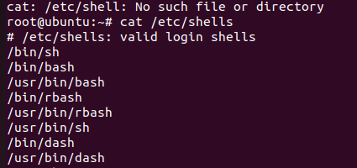

Q2. How will you get the value of a varaiable A to 50and print the value on the terminal?

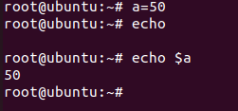

Q4. How to switch between bourne shell and bourne again shell

